Ben Robinson

R020140g@student.staffs.ac.uk

Group Game Development Project and Work Based Simulation

Written Assignment

Contents

Critical Discussion: The quality and robustness of the arguments in the critical evaluation. 2

Introduction 2

Successful Console the PlayStation 2

Background 2

Marketing Campaign 2

PlayStation Controllers 3

Effect on Sony and future releases 3

Failed Console: The Wii U 5

Background on the game and franchise 5

Marketing Campaign 5

Effect on Nintendo and future releases 6

Reflection: The quality of your reflection of the societal, commercial, and business implications of successful and non-successful games. 6

It is a new Console 6

Third Party Support 7

Conclusion The quality of your conclusions – what can we learn from this? Is it inevitable a game will succeed or fail? 7

Appendix 8

Appendix 1: Bibliography 8

Appendix 2: PlayStation Controller 9

Appendix 3: DualShock Controller 9

# Critical Discussion: The quality and robustness of the arguments in the critical evaluation.

## Introduction

Within the games industry, the release of a games console is extremely important for many developers including both the first party developers who helped create the console hoping to make a profit from the release, and the third party developers who can use the console to promote their newly released games onto the platform. The failure of a console can cause many problems in the long run including the failure to attract third party developers that mean the console and the company behind it will not be able to recover. Even with this however, many games consoles seem to have issues when being released to the public, One reason for this may be due to the marketing team behind the console failing to promote the system properly by not giving consumers a reason to buy the new console over buying its competitors or even the companies previously released console. To understand this, we will be comparing the differences between two consoles. The Sony PlayStation, which was the first console, released by the company and lead to a very successful introduction into the market, and the Nintendo Wii U which failed to convince possible consumers to buy the console leading to its overall failure in the console market.

## Successful Console the PlayStation

### Background

Sony Computer Entertainment released the PlayStation (also known as the PS1) as their first gaming console on the 29th September 1995 in European regions (9th September 1995 in America and 3rd December 1994 in Japan). As shown on the official PlayStation website related to the PlayStation (Sony, n.d.) *“PlayStation Games were the first to be released on CD and boasted advanced 3D polygon graphics”*. However, the consoles main selling point was its large amount of third-party games.

### Marketing Campaign

At the time of PlayStations release, game consoles were primarily produced by Nintendo and SEGA and mainly focused on their large first party catalogue of games. While there were many third-party developers on the consoles produced by those companies, many of them were not as popular as their first party games. With the release of the PlayStation there was a large focus on third party releases. 1,300 games were released onto the platform (according to the website List Challenges (List Challenges, n.d.)) by the end of the consoles life span, many of which were exclusive to the PlayStation. With the focus on third party games, many companies decided it best to only publish games onto the PlayStation.

One of these third party games was **Simpsons Wrestling** (Big Ape Productions, 2001). Released in 2001 the game was critically panned by many players and reviewers due to its poor graphics, boring and repetitive gameplay, and poor handling of **The Simpsons** licence (As shown in this IGN review created at the time by Doug Perry (Perry, 2001)). Even with these poor reviews the game became the eighth most selling game in the UK by The Association for UK Interactive Entertainment (UKIE) (As confirmed Ukiepida (Ukiepedia, 2019‎ )). While the large sales numbers of the game may have been due to the then current popularity of the **Simpsons** brand, these sales would not have been as large of a success if the PlayStation itself had not been as popular as it was, especially since the game has only ever been released for the PlayStation.

### PlayStation Controllers

One of the most important reasons for the success of the PlayStation was its line of controllers. Most of the information gathered about the controllers was an article from **DEN OF GEEK** created by **Matthew Byrd** (Byrd, 2020). The first of these controllers was simply known as the “PlayStation Controller” *(As seen in Appendix 2)*. The controller sported a D-pad on the left side, two buttons in the middle, labelled start and select and four buttons on the back of the controller (two on the left and two on the right). However, the most important implementation for the controller was its four face buttons on the right side of the controller labelled circle, square, triangle and cross. These buttons were important for the controller due to them being designed for universal actions between games, for example cross and circle buttons were made for either saying yes or no to an action, while square was designed for opening a menu and triangle was designed to re-centre the camera in a 3d game. This was extremely important for players due to the system having a near universal control system. Players who decided to buy a new game would not need to adjust to the controls as much whilst playing, increasing enjoyment and in turn the system. Later additions to the controller included the “Dual Analog” controller which included two analog sticks which doubled as buttons and the “DualShock” controller (As seen in Appendix 3) later added vibration to it.

### Effect on Sony and future releases

Thanks to what was previously stated, the console was able to sell 102 million units and led to the creation of the PlayStation 2 which sold over 155 million units and is still the highest grossing games console of all time. Also the DualShock controller was used for the creation of the PlayStation 2, 3 and 4 with only minor changes to its overall design and many of the design elements from the DualShock became staples in controller design for both for many of the controllers created in the years since its release such as the Wii Classic and Pro Controllers and the XBOX, XBOX 360, and XBOX One Controllers. The largest influence the PlayStation made to the games industry however was its third party focus, showing how important third party developers were for the games industry especially highlighted since Sony was technically a third party to the console market at the time, allowing other companies such as Microsoft and Valve to join in.

## Failed Console: The Wii U

### Background on the game and franchise

On the 18th November 2012, Nintendo released the Wii U as a successor to the extremely popular Wii system. Supporting HD graphical capabilities, backwards compatibility with the Wii and a secondary game pad controller which supported all the games released for the console or in some cases would allow the player to play games off the device. With all that going for the console it was surprisingly considered a failure, only selling 13 million systems within the first four years of its life span. This compares with its predecessor the Wii, which sold 71 million systems and the current Nintendo console the Switch which sold 56 million systems in the same period as set out in the graph below *(Nintendo, 2020).*

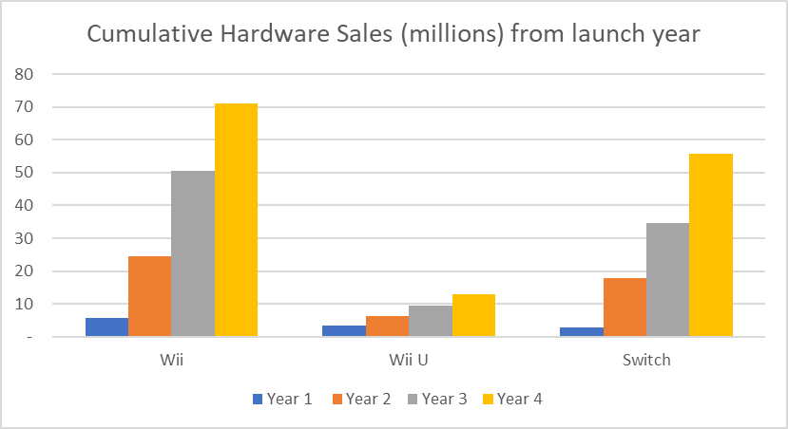

### Marketing Campaign

One of the major reasons for the failure of the Wii U was due to its marketing campaign which launched at the Electronic Entertainment Expo in 2011 *(Nintendo;IGN, 2011)*. The consoles announcement demonstrated the consoles main peripheral, the Wii U Gamepad. Due to this and the name was very similarly to its predecessor, the Wii, many possible customers believed that the Wii U was simply an add on to the Wii and did not believe it to be necessary to purchase the new console. Especially with the price of the Wii U (cost £250-£300) being far higher than buying a Wii at the time (less than £150 new). Later adverts such as the “What is Wii U” marketing campaign tried to distinguish the Wii U from the Wii in an attempt to get them to upgrade to the new system (Evidence of which shown from this video by NintenDannNC *(NintenDaanNC, 2012)*). However, even with this ploy Wii U’s sales did not increase.

Another reason for its failure was the systems lack of new games at both its launch and through its lifespan. At launch the Wii U had 23 games and many of these games were re-releases from other consoles. The most appealing release for the system **New Super Mario Brothers U** was seen more as a HD expansion to the previous entry on the Wii **New Super Mario Brothers Wii**. While some new game releases such as **Mario Kart 8, Donkey Kong Country Tropical Freeze** and **Super Smash Brothers for Wii U** did sell well and increased the sales of the Wii U. However, it was not enough to increase console sales.

Later in the switches life span many third party game companies chose not to support the system due to both its previously mentioned failures in the market, its lack of power when compared to its competitors in the market at the time, and its over reliance to the Gamepad.

### Effect on Nintendo and future releases

As shown in a 2014 article in Forbes (Tassi, 2014) sales for the Wii U were down by a large margin. Due to the issues associated with it, many Nintendo executives including current CEO Satoru Iwata took pay cuts of up to 50% as a symbolic gesture, admitting the failure of the console.

Many of the issues related to the release of the Wii U were resolved when Nintendo’s next home console the Switch was released. It was marketed as a separate entity from the Wii family of products and while its launch line-up was far smaller than the Wii U’s, many of the games were new products which could not have been played anywhere else. Nintendo also announced many more games to be released in the months following its release including many of those games being from third party developers.

# Reflection: The quality of your reflection of the societal, commercial, and business implications of successful and non-successful games.

When comparing the PlayStation and the Wii U there are many similarities in their approach, such as the marketing of the controller. However, many of the differences between them show why one failed and the other succeeded as explained below.

## It is a new Console

The first was the difference was how they approached the idea of it being a new console. The Wii U was the successor to the Wii, however, due to their over focus on the controller and the similarities in the names, the Wii U was seen as an add on to the Wii as opposed to its successor. In contrast the PlayStation was fully marketed as being new, a new console, a new controller and even a new company entering the console market. This was in addition to the masses of new games and third-party developers that can only be played on the console. This shows the importance of branding a game or console as being brand new since it turned away many potential customers who already owned the previous system.

Nintendo learnt from this mistake and their next home console, The Switch, was marketed as being a completely different experience from any of Nintendo’s consoles and easily overshadowed the Wii U in terms of sales.

## Third Party Support

Another point of comparison for the consoles was the third party support they both held. With the PlayStation, third party games were considered to be its primary selling point, having thousands of third-party games. The Wii U on the other hand lacked third party games. This was due to its overreliance on the Wii U Game pad and its lack of power compared to its competitors at the time, the Xbox One and PlayStation 4.

# Conclusion The quality of your conclusions – what can we learn from this? Is it inevitable a game will succeed or fail?

Overall, as found from the research conducted, many possible issues arise from the release of a game or a console. However, one of the biggest points to look at is its marketing and how the game or console can be differentiated from others. The PlayStation luckily had the advantage of being the first console released by Sony and due to its acceptance of third-party companies on the platform, it increased the popularity for the system. Meanwhile the Wii U failed to show consumers that it was worth buying and ended with many third party companies refusing to work with them and eventually lead to its downfall.

# Appendix

## Appendix 1: Bibliography

Big Ape Productions, 2001. *The Simpsons Wrestling.* PlayStation: EA.

Byrd, M., 2020. *The Evolution of the PlayStation Controller.* [Online]   
Available at: https://www.denofgeek.com/games/playstation-controllers-history/  
[Accessed 1 June 2020].

Google, 2005. *Youtube.* [Online]   
Available at: https://www.youtube.com/  
[Accessed 27 May 2020].

List Challenges, n.d. *All North American Release Playstation Games.* [Online]   
Available at: https://www.listchallenges.com/all-north-american-release-playstation-games  
[Accessed 2020 May 2020].

NintenDaanNC, 2012. *[Commercials] What is Wii U? - All Commercials.* [Online]   
Available at: https://www.youtube.com/watch?v=iOwIoWPGJwc  
[Accessed 27 May 2020].

Nintendo;IGN, 2011. *Nintendo Wii U Trailer (E3 2011).* [Online]   
Available at: https://www.youtube.com/watch?v=4e3qaPg_keg  
[Accessed 06 June 2020].

Nintendo, 2020. *IR Information : Sales Data - Dedicated Video Game Sales Units.* [Online]   
Available at: https://www.nintendo.co.jp/ir/en/finance/hard_soft/index.html  
[Accessed 31 May 2020].

Perry, D., 2001. *Simpsons Wrestling - IGN.* [Online]   
Available at: https://www.ign.com/articles/2001/04/06/simpsons-wrestling  
[Accessed 06 June 2020].

Sony, n.d. *PlayStation | PS one | PlayStation.com.* [Online]   
Available at: https://www.playstation.com/en-gb/explore/ps1/  
[Accessed 31 May 2020].

Tassi, P., 2014. *Wii U Sales Down 36%, Nintendo Executives Taking Pay Cut.* [Online]   
Available at: https://www.forbes.com/sites/insertcoin/2014/01/29/wii-u-sales-down-36-nintendo-executives-taking-pay-cut/  
[Accessed 31 May 2020].

Ukiepedia, 2019‎ . *Ukiepedia.* [Online]   
Available at: https://ukiepedia.ukie.org.uk/index.php/UK_Top_Selling_Games_2001  
[Accessed 06 June 2020].

## Appendix 2: PlayStation Controller

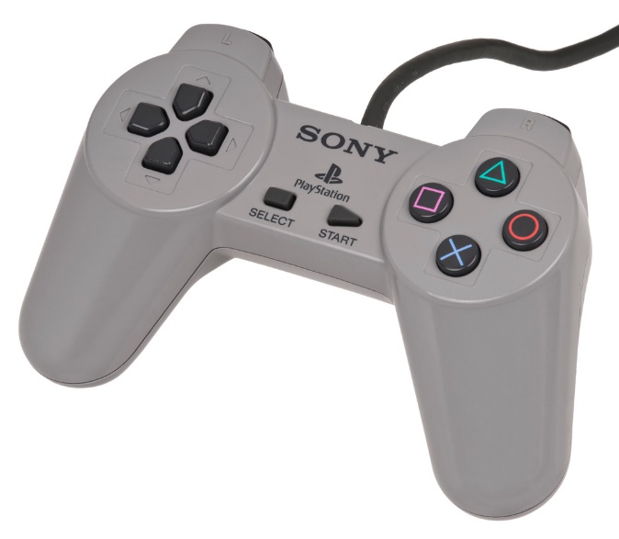

## Appendix 3: DualShock Controller

